JavaScript Getting Started

Zawartość

## JavaScript Beginnings

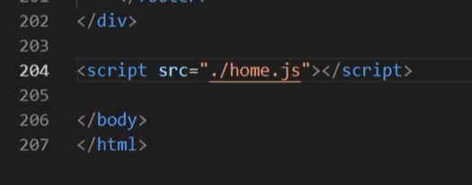’

Add js file wit script tag.

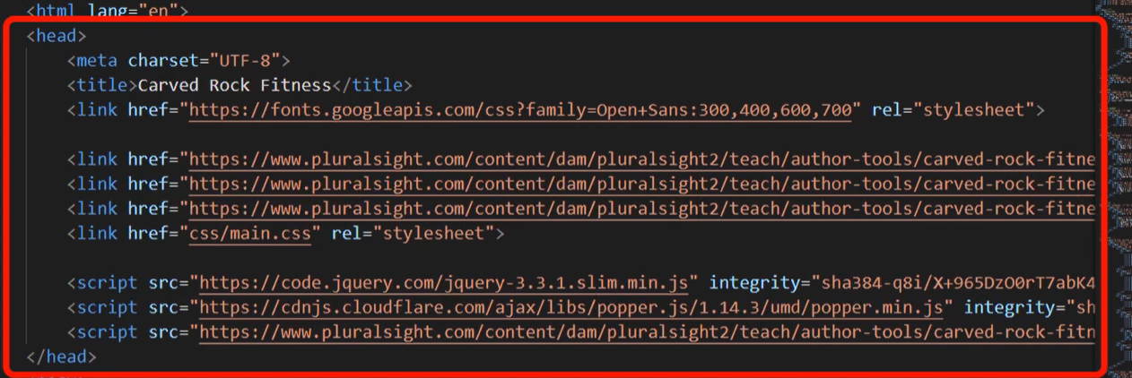

Or add to head

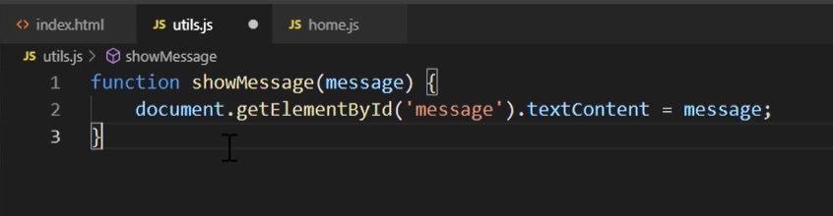

Function definition is easy. Use keyword, set name and pass a parameter which will be use.

Document is our html page. We can get all fields tags and set content to different.

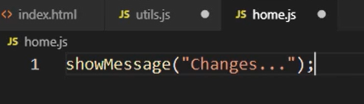

To invoke method only use it and pass required args.

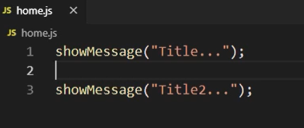

All function is interpreted by browser from top left to right down.

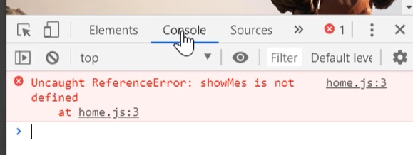

To see errors use Console in browser.

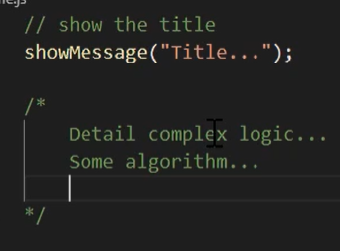

Comments works in the same way like in VS 2019;

## Variable

Is three type keyword to declare value. Var don’t use it, Let when variable can be modified and const for not modificated value

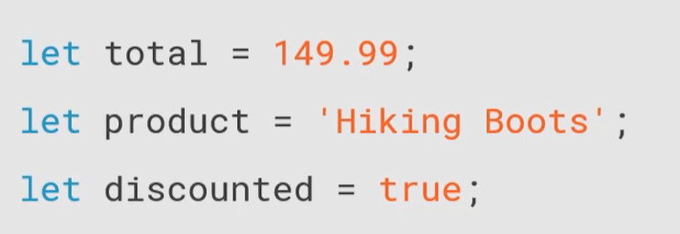

Initialization is easy use keyword name of variable and assign a value.

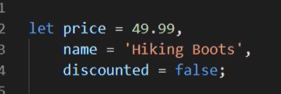

When is a lot the same type value it can be initialize in block with (coma), and on the end ;(semicolon)

Name value with camelCase

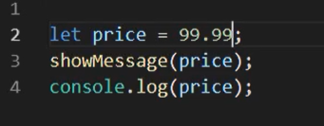

Value can be check in console.log.

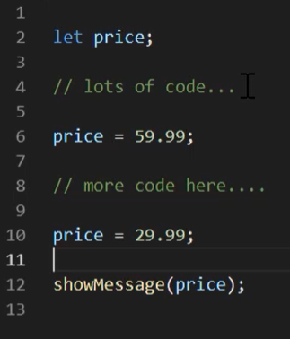

Let value can be override.

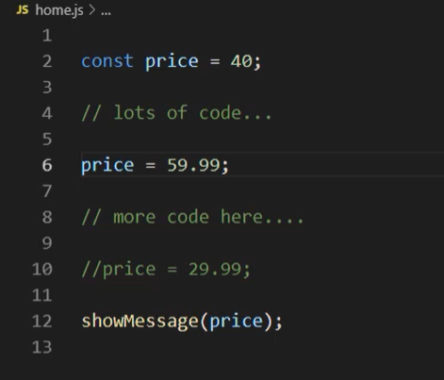

Const is immutable and can’t be change.

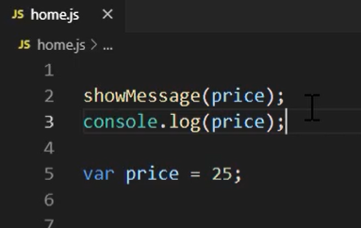

And var the most hate thing in js. Is something like hoisting we can use variable with var keyword because hoisting and all vars are going to the top of js document but we don’t have a value. Assign operation is in 5 line so in 2nd and 3rd line we have undefined. Compilator don’t know anything about value to 5th line after value is 25. Var doesn’t have a scope so if we declare car between {} it will be available globally ☺

## Type And Operation

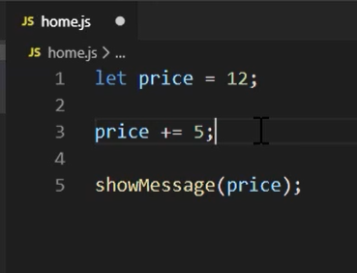

Number – we can do all mathematic operation.

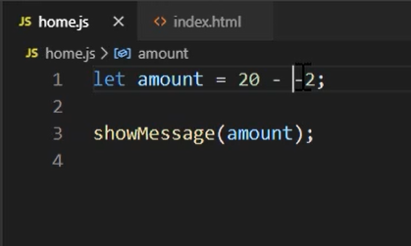

Negative number. If you do something like this it will be 22 ☺.

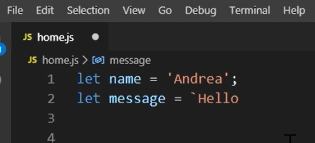

String

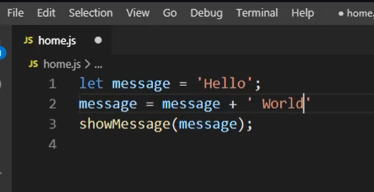

Concatenation

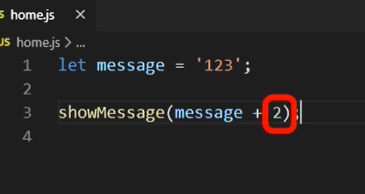

Type is convert on first variable type in this example it is a string so we have in msg 1234 ☺

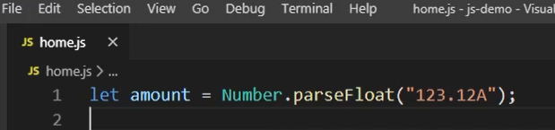

To change string to num use parse.

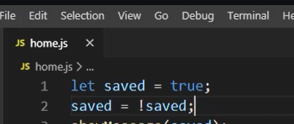

Boolean

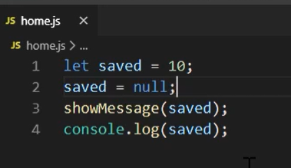

Null when object doesn’t exists in memory.

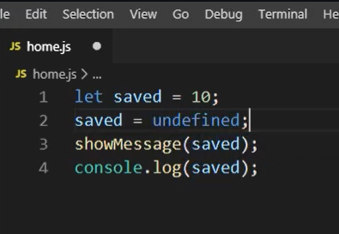

Undefined When compiler doesn’t know what is this.

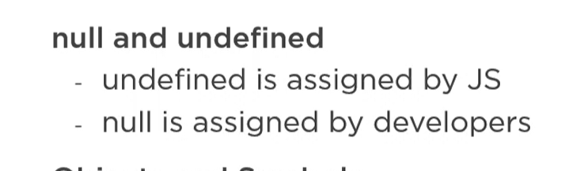

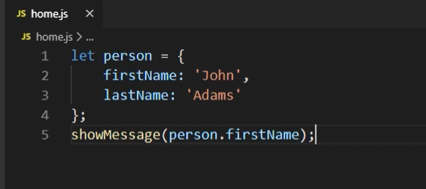

Objects

## Flow

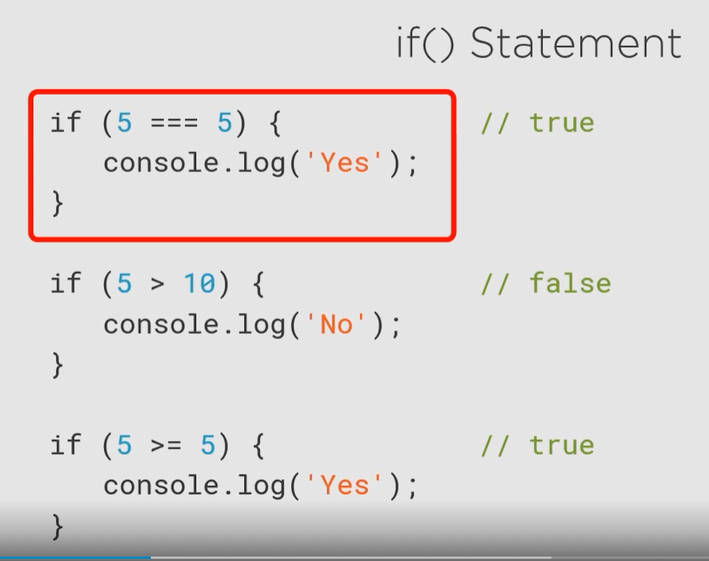

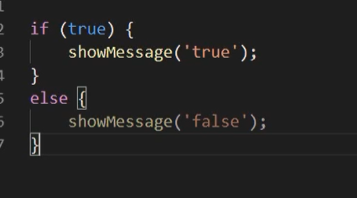

=== check param and type

== check value and convert type

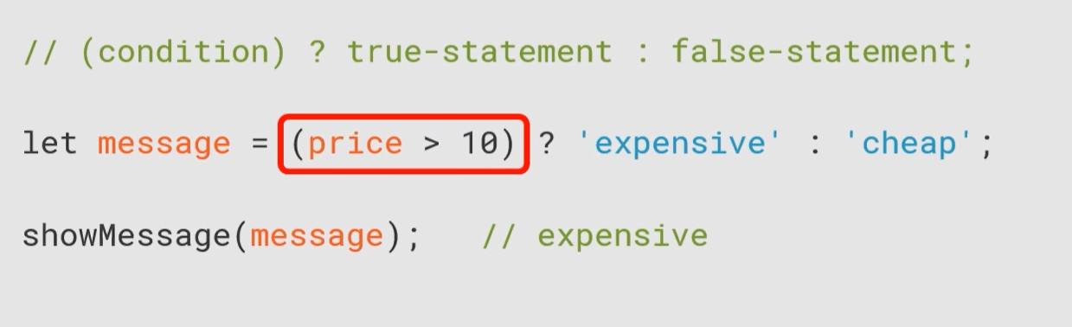

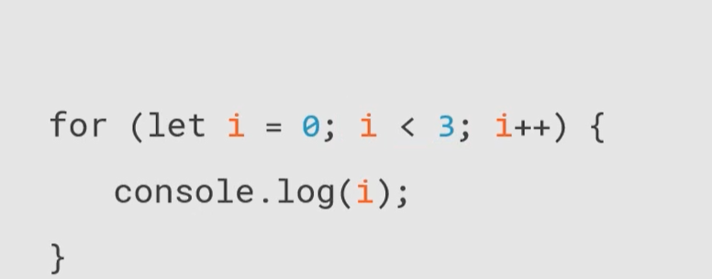

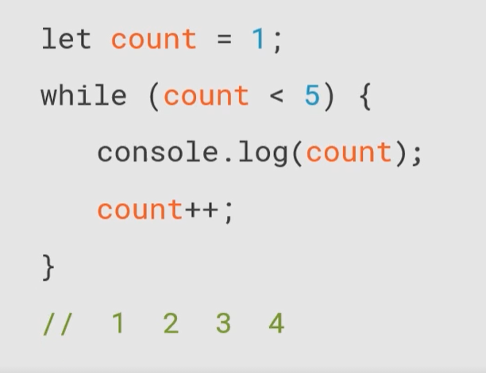

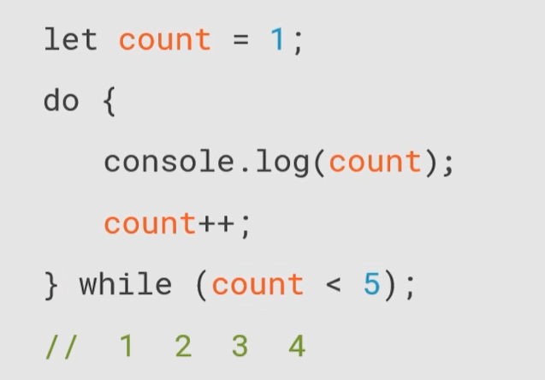

## Functions

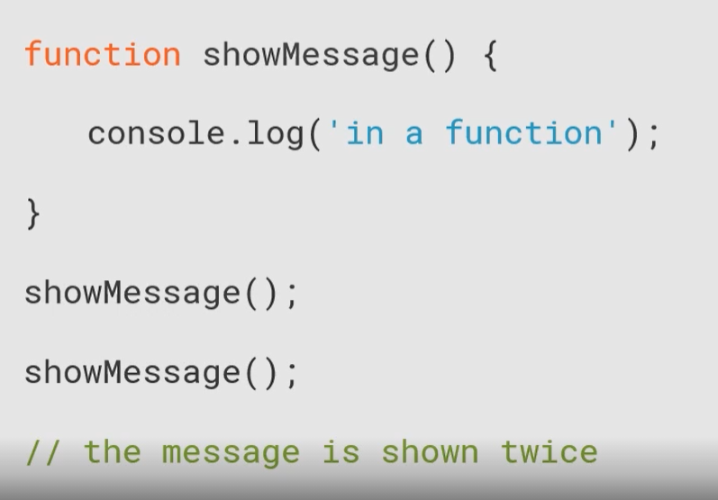

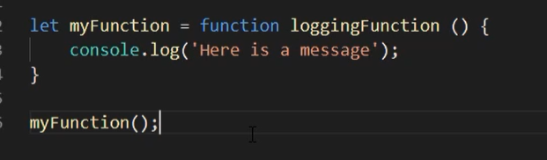

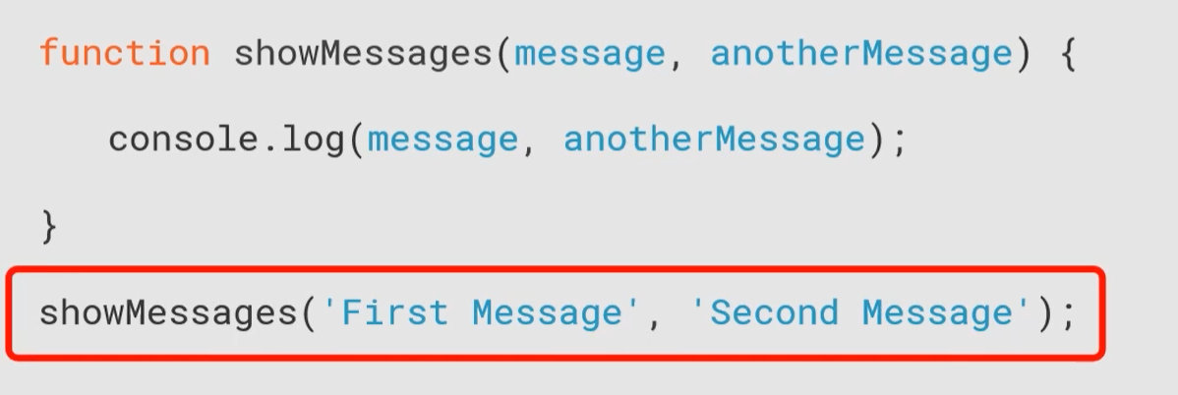

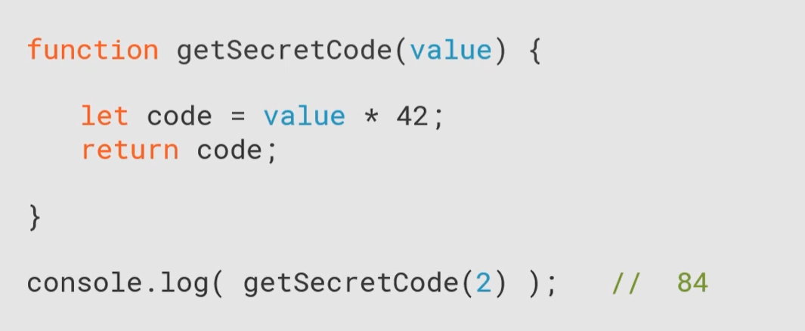

## Scope and Hoisting

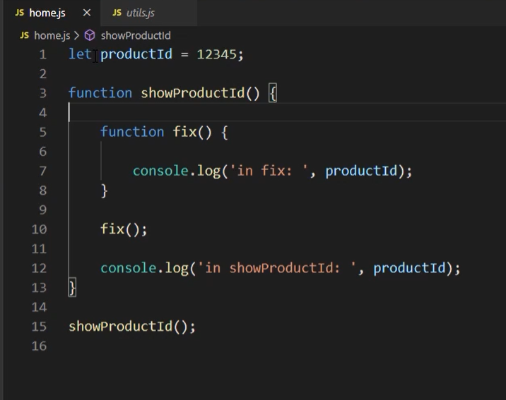

productId is in global

fix() is local

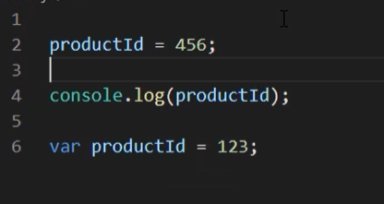

Hoisting. Var is declare in js file but is assigned in top part of document. And of course console return 456 number. ☺ Bro it is JS.

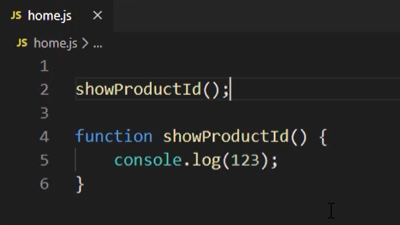

It works the same in function. Console result is 123

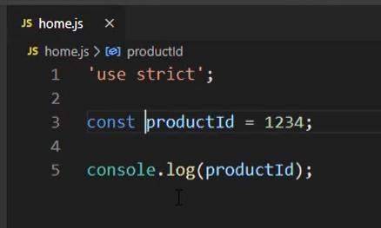

Remember always assign value to const or let or use strict mode. But more used is first way.

## Objects and DOM

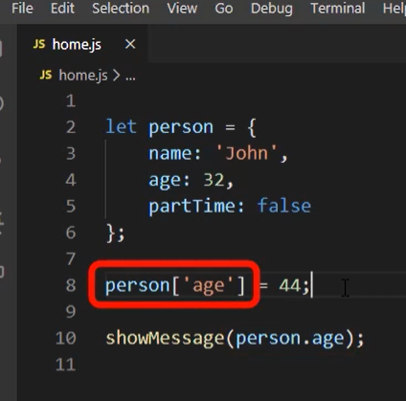

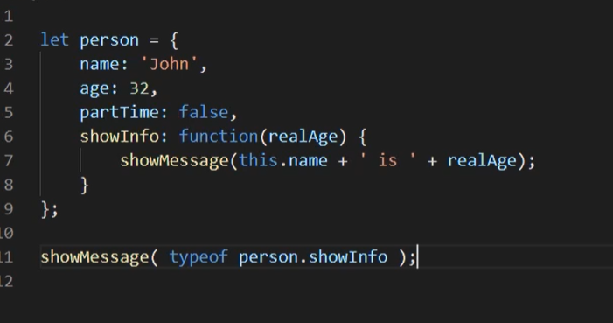

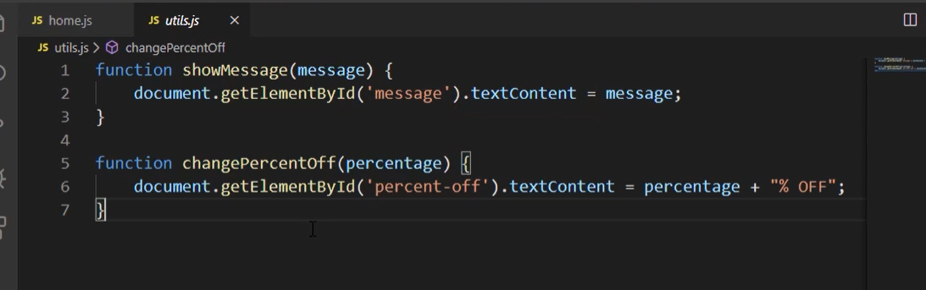

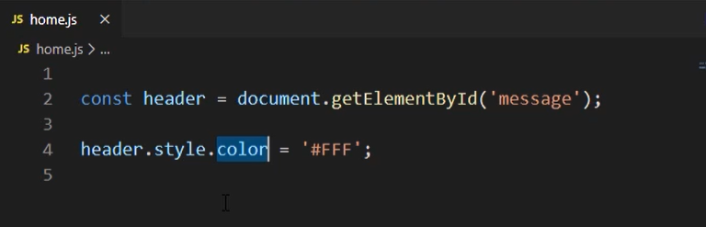

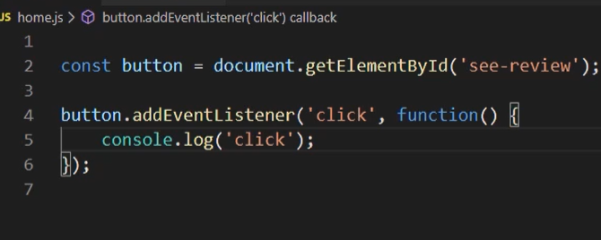

## Arrays

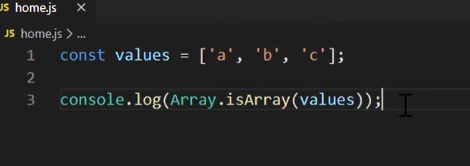

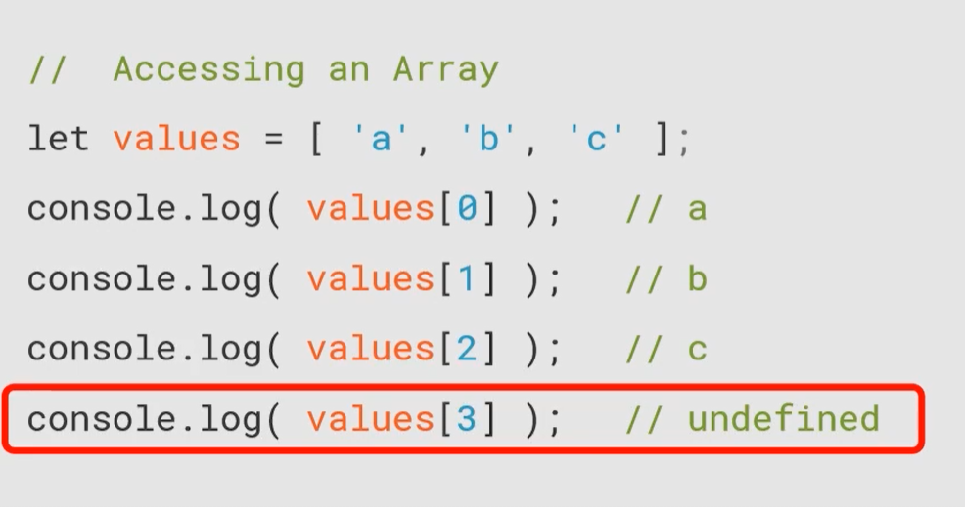

[3] doesn’t exist in array

## Array Manipulation

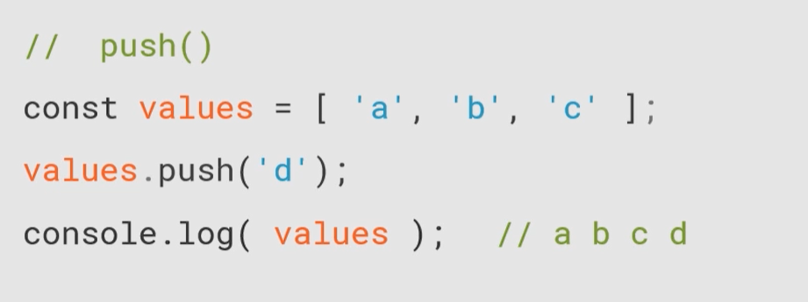

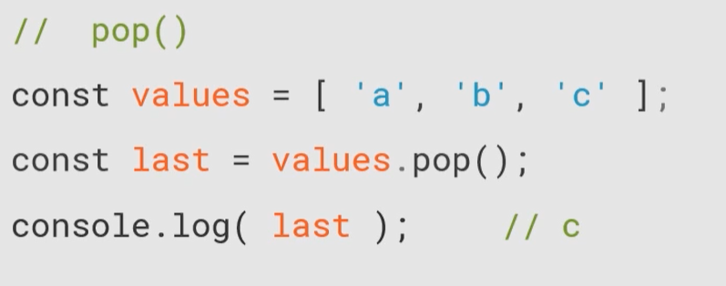

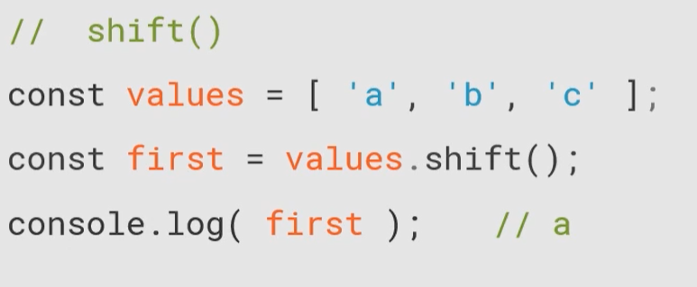

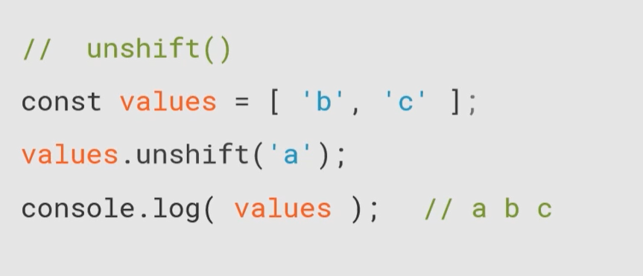

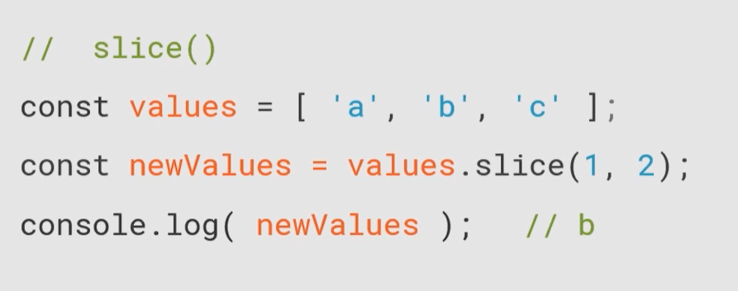

From to but to is before

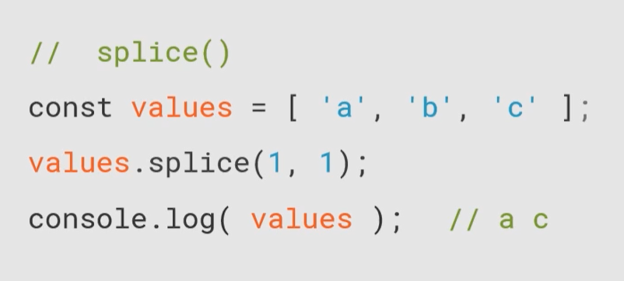

Splice for cut out one element from position or delete element from this position

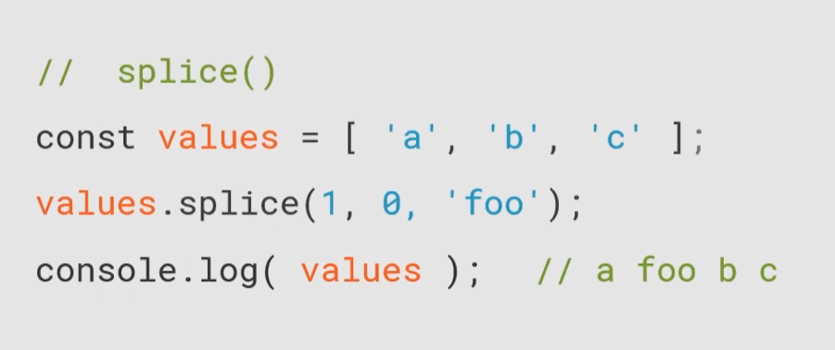

Set pointer on 1 position, don’t delete element and input foo

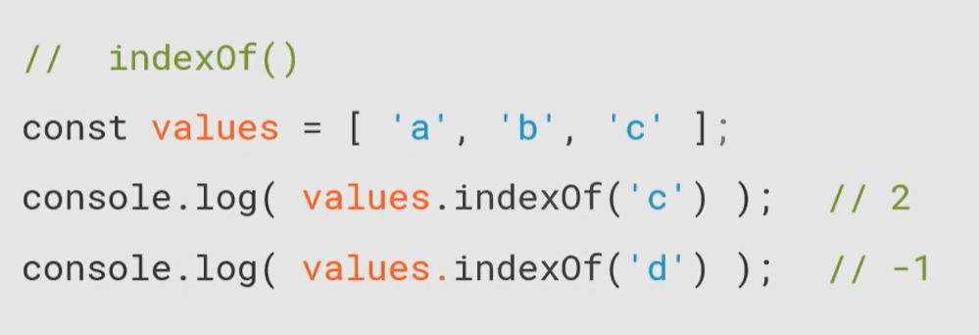

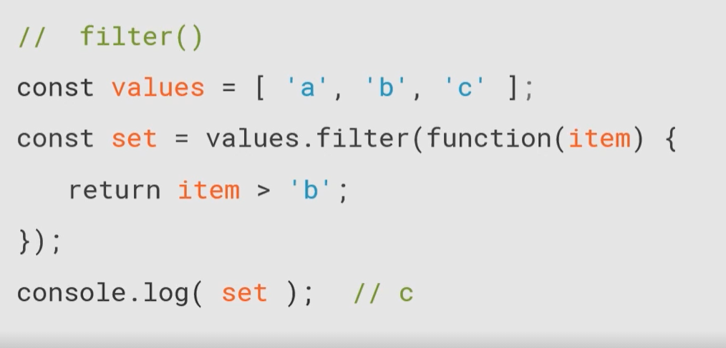

For each element function will be call once

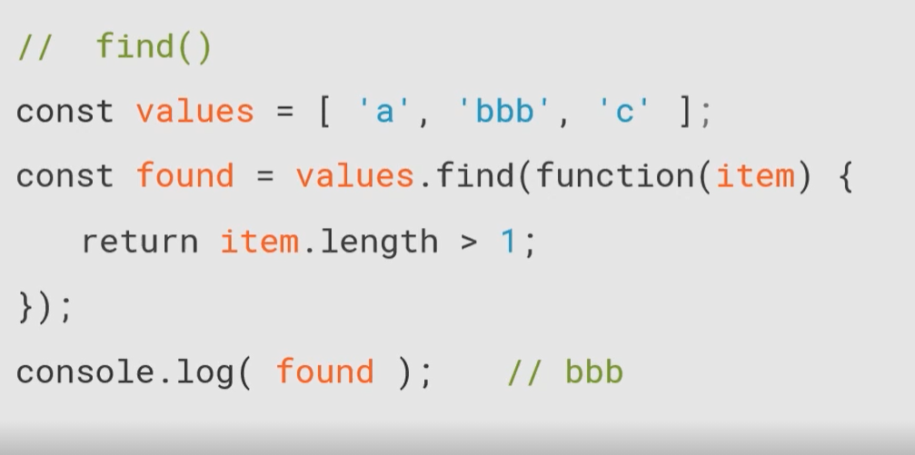

For each element function will be call once element which is greater than length 1 is bbb always take first element which fulfill statement

